289.101 Assignment Two

Annalisa Fleming & Tommy Secker

**Website URL:**

**Image Sources:**

The following images thanks to:

<https://harrypotter.fandom.com/wiki/Weasleys%27_Wizard_Wheezes>

|  |  |  |
| --- | --- | --- |
|  |  |  |
|  |  |  |
|  |  |  |
|  |  |  |

Image courtesy of:

<https://www.care.com/c/stories/4051/10-easy-magic-tricks-for-kids/en-ie/>



Image courtesy of:

<http://www.fanpop.com/clubs/weasleys-wizard-wheezes/images/39130024/title>

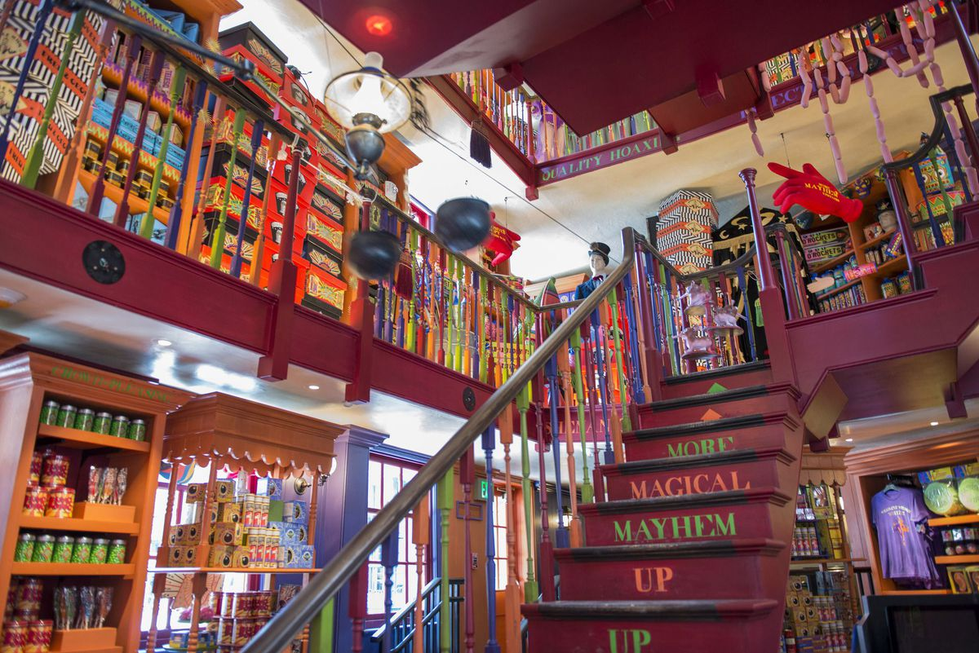

Image courtesy of:

x<http://themeparkadventure.com/universal-orlando-unveils-diagon-alley-plans/resources-digitalassets-weasleys-wizard-wheezes/>

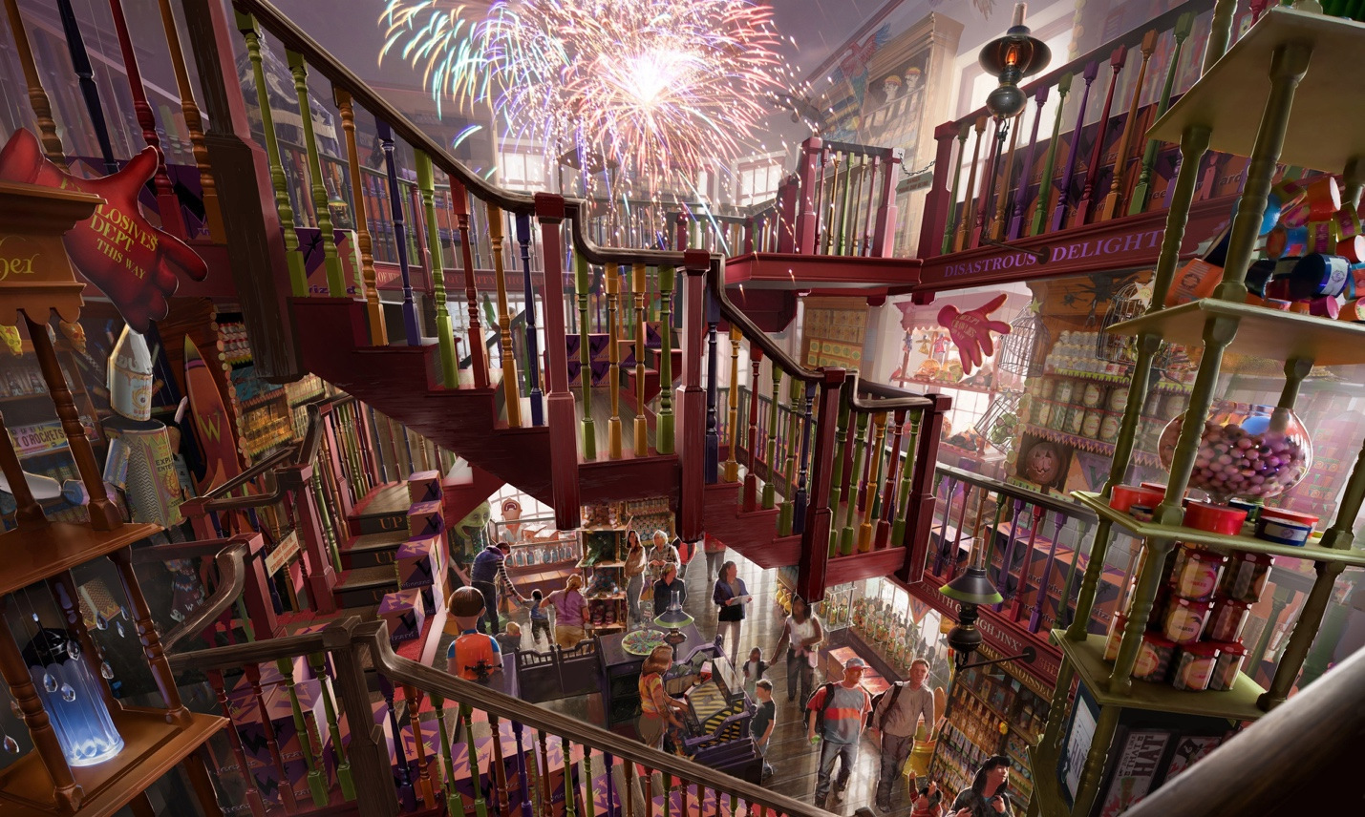

Image courtesy of:

<http://www.the-leaky-cauldron.org/2017/09/04/take-the-weasleys-wizard-wheezes-vr-challenge/>

